MINISTRY OF JUSTICE, LEGAL AND PARLIAMENTARY AFFAIRS

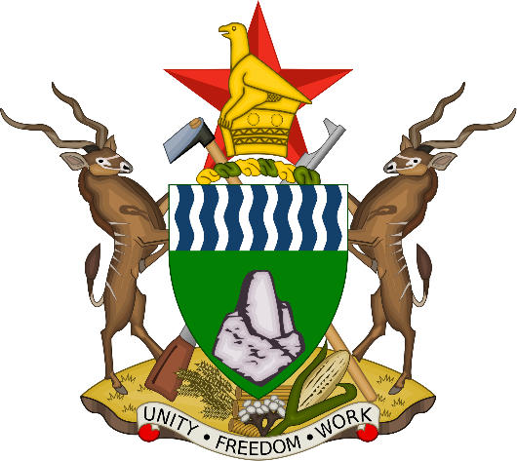

COMMENTS BY THE MINISTER OF JUSTICE RE: HIGH COURT DECISION IN THE MATTER OF 1. MUSA KIKA VS MINISTER OF JUSTICE AND 18 OTHERS HC 2125/21;
AND 2. YOUNG LAWYERS ASSOCIATION OF ZIMBABWE VS JUDICIAL SERVICE COMMISSION AND 2 OTHERS HC2166/21

- We have taken note of the decision made by the Court, and as a Country which respects the rule of law, we will respect that decision, but you must also know that as litigants ,we have our rights which are protected by the law.

- With the greatest of respect, we do not agree with the decision of the Court for so many reasons and for that reason, we have already instructed our lawyers to file an appeal first thing on Monday morning.

- We do not understand how the Honourable Justice Zhou insisted on proceeding with the matter after we sought his recusal because he is clearly conflicted.

- We are also at a loss as to how the Honourable Judge President of the High Court was excluded from being cited in the litigation which included all Judges of the High Court who have acted in the Supreme and Constitutional Courts.

- We are further alarmed that these proceedings went on through the night up to midnight. This is a typical case of a night court, consisting of night judges and night lawyers.

- The Judges have not given us the judgment- they know that it is our right to file a notice of appeal, and we can only do that after we have been favoured with reasons of their decision, which they have not provided us with. Our conclusion is that they are therefore attempting to disable us from filing an appeal because they know that after we file an appeal, their decision will be suspended.

- We have nevertheless requested our lawyers to put together our reasons for the appeal with the little information that they have provided us with.

- One issue that is worrying which even the most basic layman would want to know is that the Judges appear to base their decision on the interpretation that is given to section 328 (7) of the Constitution and the new section 186 (4) of the Constitution but surprisingly, the interpretation of the provisions was not before them, and secondly, the institutions that put into effect these provisions that is Parliament and the President were not cited in this application- how do they make such a decision without the benefit of having heard the side of Parliament and President who legislated these provisions? How does the Judiciary turn itself into an Executive and Legislature at the same time?

- This is a typical case of judicial overreach and as Government, we are not going to accept that. This is clear violation of the doctrine of separation of powers- the Judiciary should know where it ends. It is not the big brother of the other two arms of the State which it wants to purport to be. It is just another arm of the State.

- I must also mention and make it very clear that we are aware of multi-lateral and foreign organisations who have poured in a lot of money through the Zimbabwe Lawyers for Human Rights to capture various state institutions and to destabilise the Government.
- The situation now in this country is that there is a risk of judicial capture where the Judiciary has been captured by certain elements both within and outside Zimbabwe who want to destabilise the second Republic.

- We are also aware of certain members of the opposition, the MDC Alliance, who are being paid monthly allowances for causing turmoil in this country and for being arrested.

- The time may now have come to expose all these malcontents and economic saboteurs who are not sleeping until they bring down the second Republic.

- We are now going to poke the enemy in the eye and confront it.

- The time has come also to look at the transformation of the Judiciary- have we really succeeded as a country to transform the Judiciary? You need to only look at various decisions that have been made by a certain group of Judges which are meant to tarnish the second Republic.

- How does one Judge whom we are aware of the circumstances of his appointment continue to make decisions that are against then Government? In the eyes of the Judge, does it mean that the Government is always wrong? And how are cases allocated at the High Court? Why does a certain group of Judges including that Judge continue to be allocated cases in which the second Republic is involved in?

- What is going on in the Judiciary, more particularly at the High Court? A decision has been made that Judges of the Constitutional Court and Supreme Court are benefiting from Constitutional Amendment Number 2- what about Judges of the High Court? Are they not going to benefit from the same Amendment?

- We were told by our lawyers they had agreed with the applicant’s lawyers that the filing of papers and pleadings would be done up to Thursday next week, but the Judges refused to accept these timelines because they were so determined to do away with the decision that had been made by His Excellency.

- I want to make it clear today that we do not accept the decision of the High Court. We have a serious situation of a Judiciary that has been captured by foreign forces in this Country.

- We are going to exercise our right in terms of the law and file an appeal against this baseless and meaningless decision of the High Court.

-END-

